Multiple-choice section – choose the correct answer

Question 1 [7.1]

‘Three more than a number gives a solution of 22’ is:

A *n* + 3 = 22 B 3*n* = 22 C 3 – *n* = 22 D 22 = *n*

Question 2 [7.1]

Use substitution to find the value of *a* in 2*a* − 5 = 11.

A *a* = 3 B *a* = -3 C *a* = 8 D *a* = -8

Question 3 [7.2]

Solve 2*x* = 10.

A *x* = 8 B *x* = 5 C *x* = 20 D *x* = 12

Question 4 [7.2]

What is the value of *y* where *x* = 2?

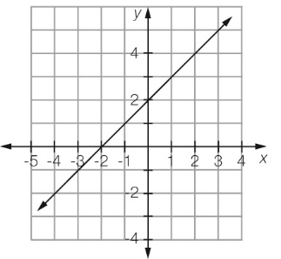

A *y* = 0 B *y* = 3 C *y* = 4 D *y* = 2

Question 5 [7.4]

The solution of the balance diagram is:

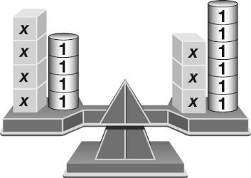

A *x* = 2 B *x* = -2 C 4*x* = 3*x* – 2 D *x* = 3

Question 6 [7.2]

Solve 3*b* − 5 = 4.

A *b* = 3 B *b* = 4 C *b* =  D *b* = 27

Question 7 [7.3]

Solve 3(*x* − 6) = 21.

A *x* = 1 B *x* = 13 C *x* = 5 D *x* = 9

Question 8 [7.4]

Solve 4*d* − 2 = 3*d* + 10.

A *d* = 2 B *d* = 8 C *d* =  D *d* = 12

Question 9 [7.5]

Jason buys 5 chocolate bars and gets 50 cents change from $5.00. How much was each chocolate bar?

A $1.00 B $1.50 C $0.90 D $1.10

Multiple-choice results: ___ / 9

Short answer section

Question 10 1 mark [7.3]

Here is David’s working to solve the equation  – 5 = 7. David has made an error. Circle the line of working where the error appears.

David’s working

 − 5 = 7

 = 12

*x* = 4

Question 11 1 mark [7.2]

This graph describes the costs to hire a taxi. What is the cost of hiring a taxi to travel  
a distance of 5 km?

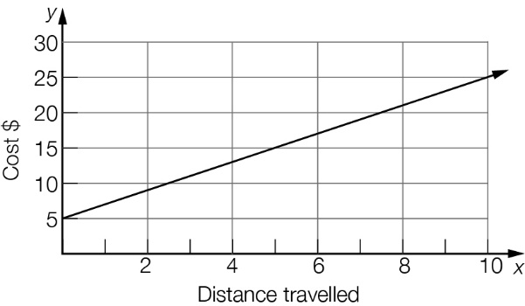

Question 12 1 mark [7.1]

Write an equation for the following using the letter *n* to represent the number.

Twice a number gives a result of twenty-two.

Question 13 2 marks [7.1]

Check by substitution whether the number in the brackets is a solution for the equation.

3*x* − 5 = 13 (*x* = 6)

Question 14 1 mark [7.1]

Write an equation for the rule below, using the given pronumerals for each of the   
quantities described.

Force (*F*) is equal to mass (*M*) multiplied by acceleration (*a*).

Question 15 4 marks [7.2]

Use the following graph to find the value of:

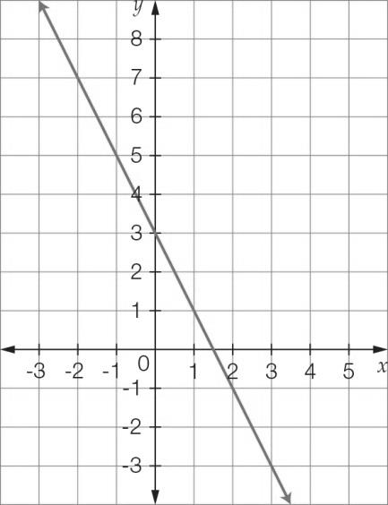

(a) *y* where *x* = 1 (b) *y* where *x* = 2



(c) *x* where *y* = 5 (d) *x* where *y* = 3

Question 16 4 marks [7.3]

Solve each of these linear equations using algebra.

(a) (b)  
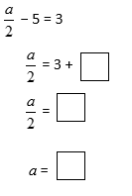 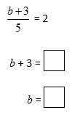

Question 17 3 marks [7.2]

Mia buys a cup of coffee each weekday morning. On two mornings she also buys a sandwich for $4.50. She spends a total of $26.50 for food and drink over the five mornings.

(a) Write an equation to represent this statement.

(b) What is the cost of each cup of coffee?

Question 18 3 marks [7.3]

Solve the following equation.

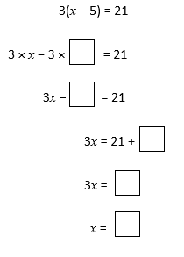

Question 19 6 marks [7.2]

Write the following statements as equations and then find the value of the unknown.

(a) The sum of three times a number and one is ten. What is the number?

(b) A number is doubled and then has six subtracted from it. The result is eight. What is the number?

Question 20 2 marks [7.4]

Use the diagram to calculate the value of *x*.

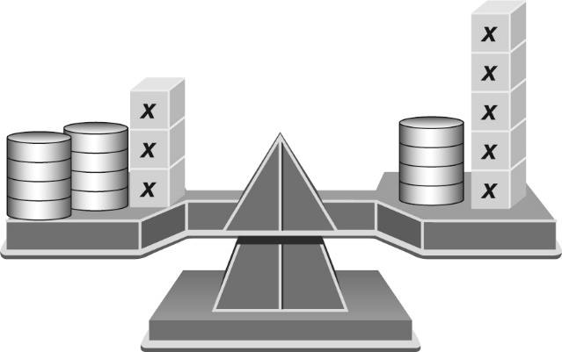

Question 21 3 marks [7.4]

Complete the first line of working and then complete the solution to the equation.

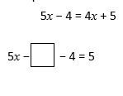

Question 22 3 marks [7.4]

By drawing the lines *y* = *x* and *y* = 2 − *x* on the number plane below, use the point of intersection to solve the equation *x* = 2 − *x*.

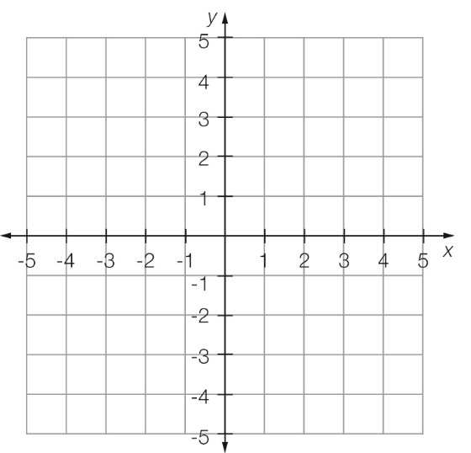

Short answer results: ___ / 34

Extended answer section

Question 23 7 marks [7.2, 7.3, 7.5]

A 5 L bucket is filled to the top. It has a slow leak so that 500 mL of water leaks out every minute. The rate of leakage is shown in the graph.

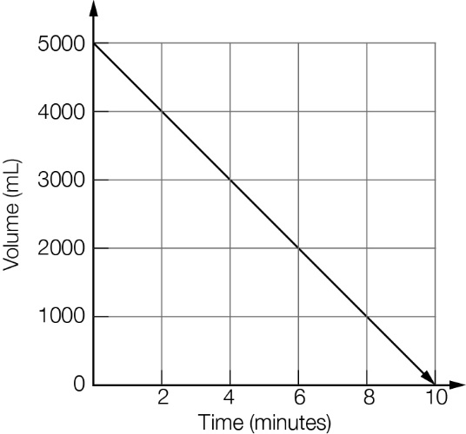

(a) How much time does it take for the bucket to empty?

(b) What does the point (0, 5000) represent?

(c) How much time has passed when there is 3500 mL left in the bucket?

(d) How much water is left in the bucket after 4 minutes?

(e) How much water is left after 7 minutes?

(f) How much water has leaked from the bucket after 8 minutes?

(g) Circle the correct equation for the graph.

A *t* = 500 − 5000*V* B *t* = 5000 − 500*V* C *V* = 500 − 5000*t* D *V* = 5000 − 500*t*

Extended answer results: ___ / 7

TOTAL test results: ___ / 50